# Ohlendorf Intercom Testing

RTP streams captured in wireshark.

Communication direction: CM-A -> CM-C.

Imported into Audacity using CMA RTP talker specifications:

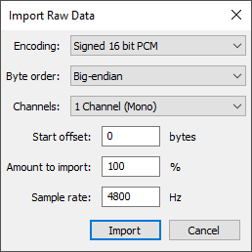

## **Test Using Generated Tone**

##### **@ 1 Vrms**

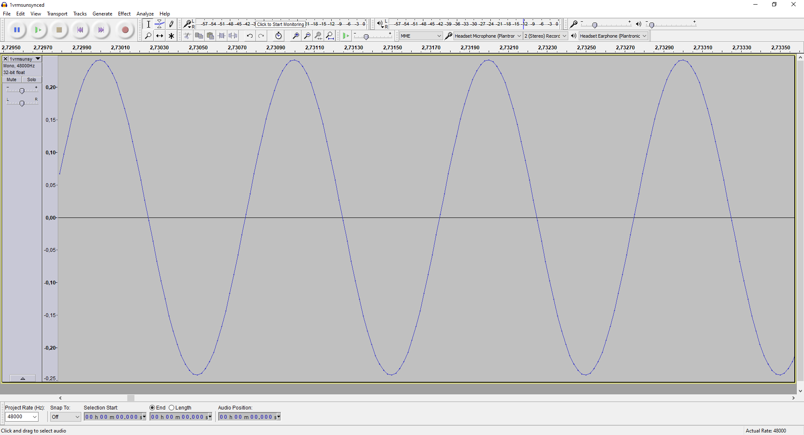

##### **@ 3 Vrms**

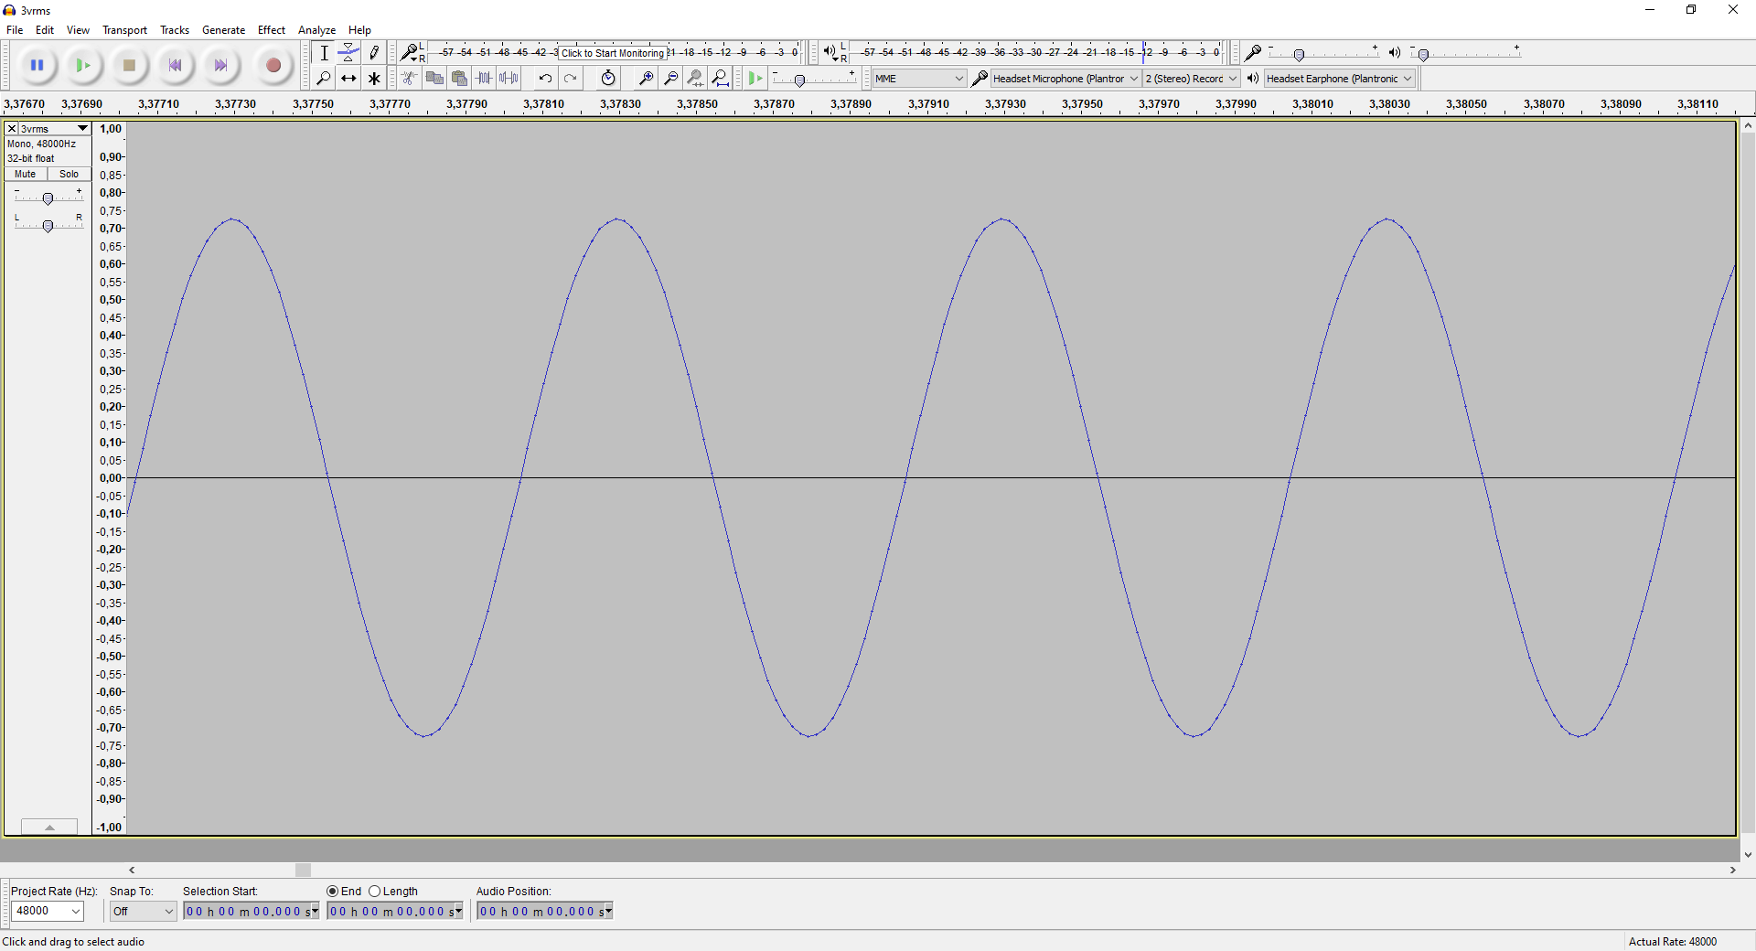

##### **@ 3.1 Vrms**

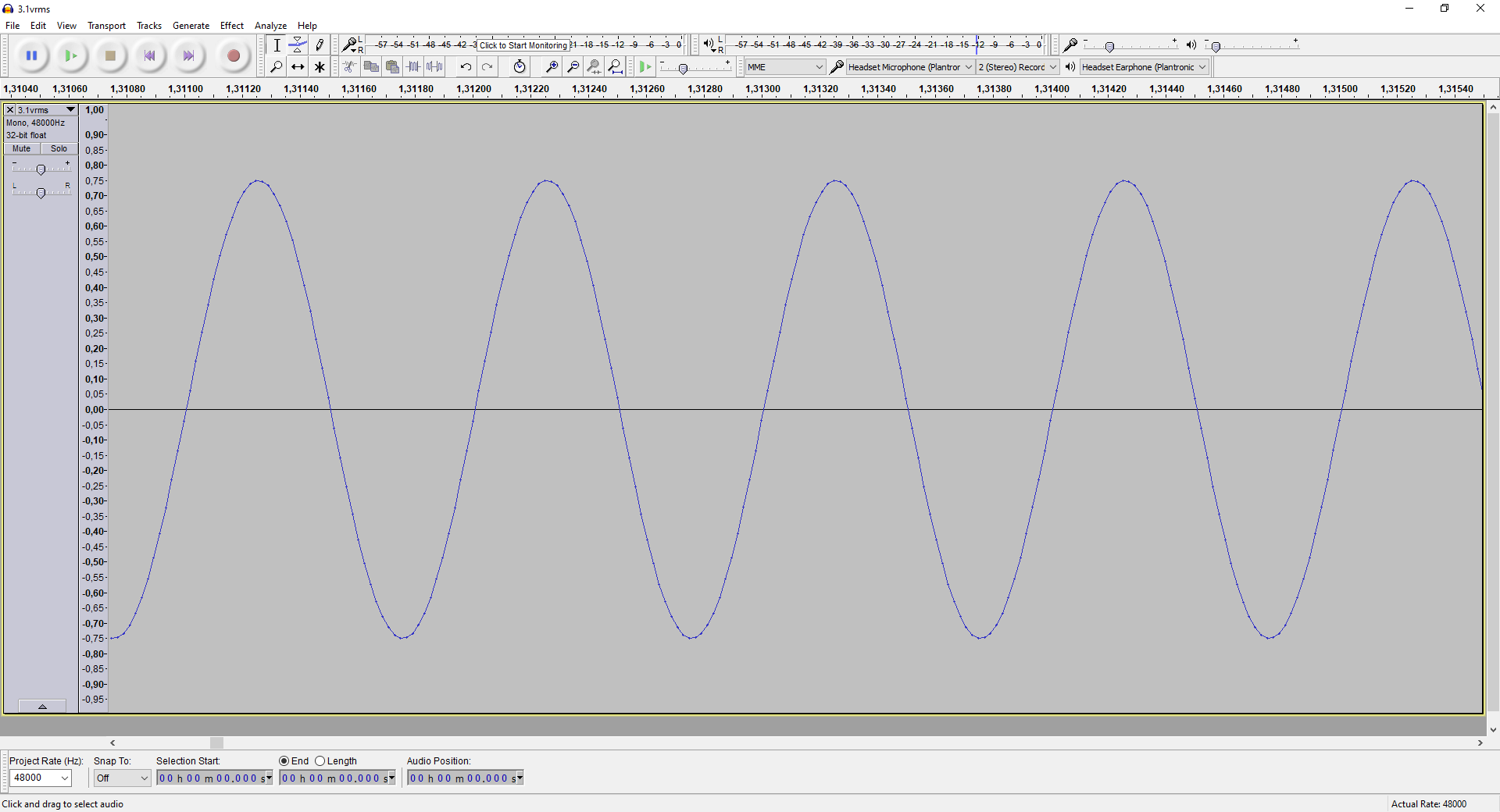

##### **@ 4.2 Vrms**

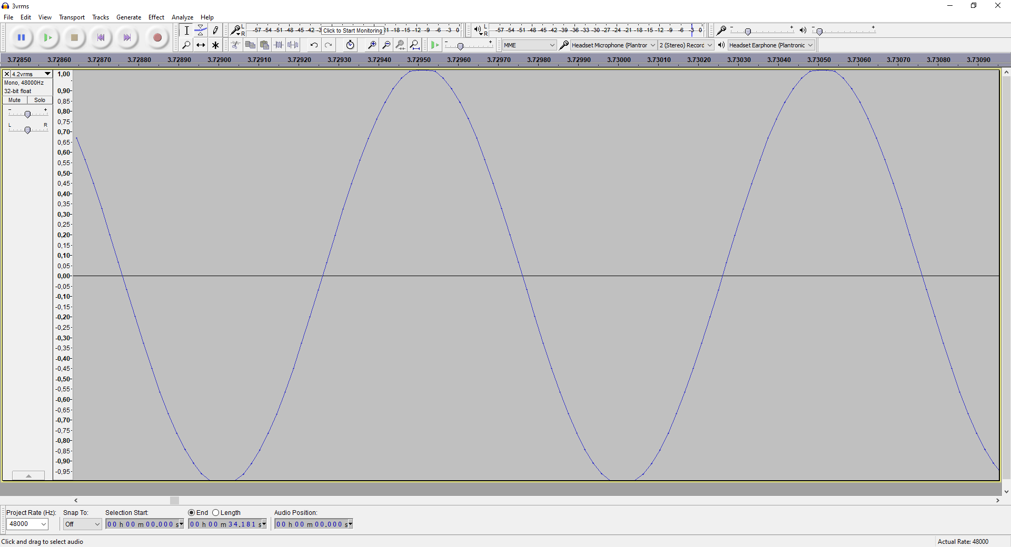

##### **@ 4.3 Vrms**

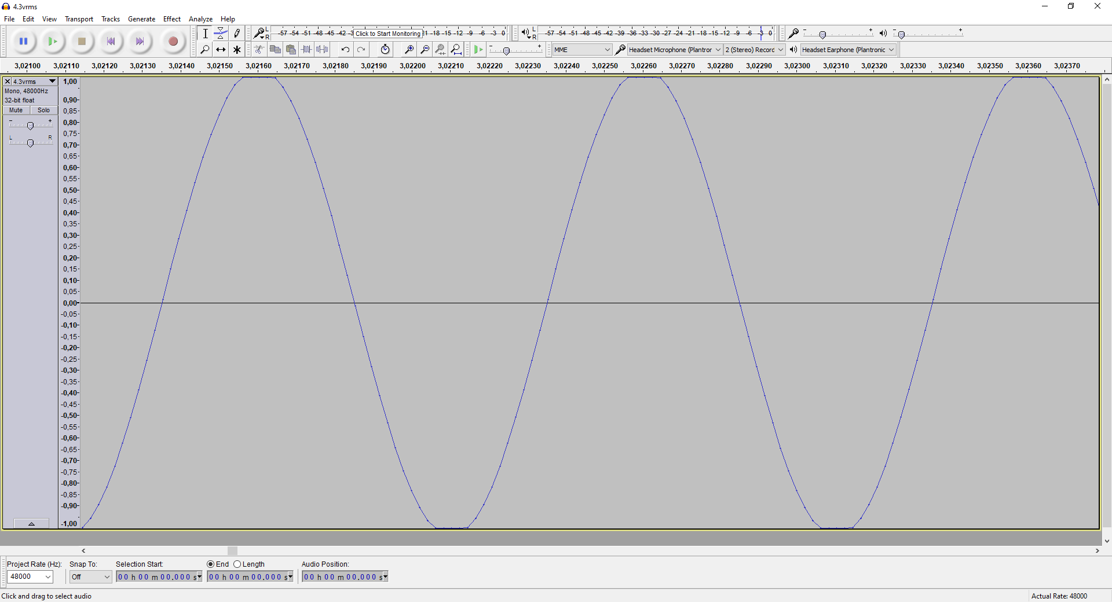

##### **@ 5 Vrms**

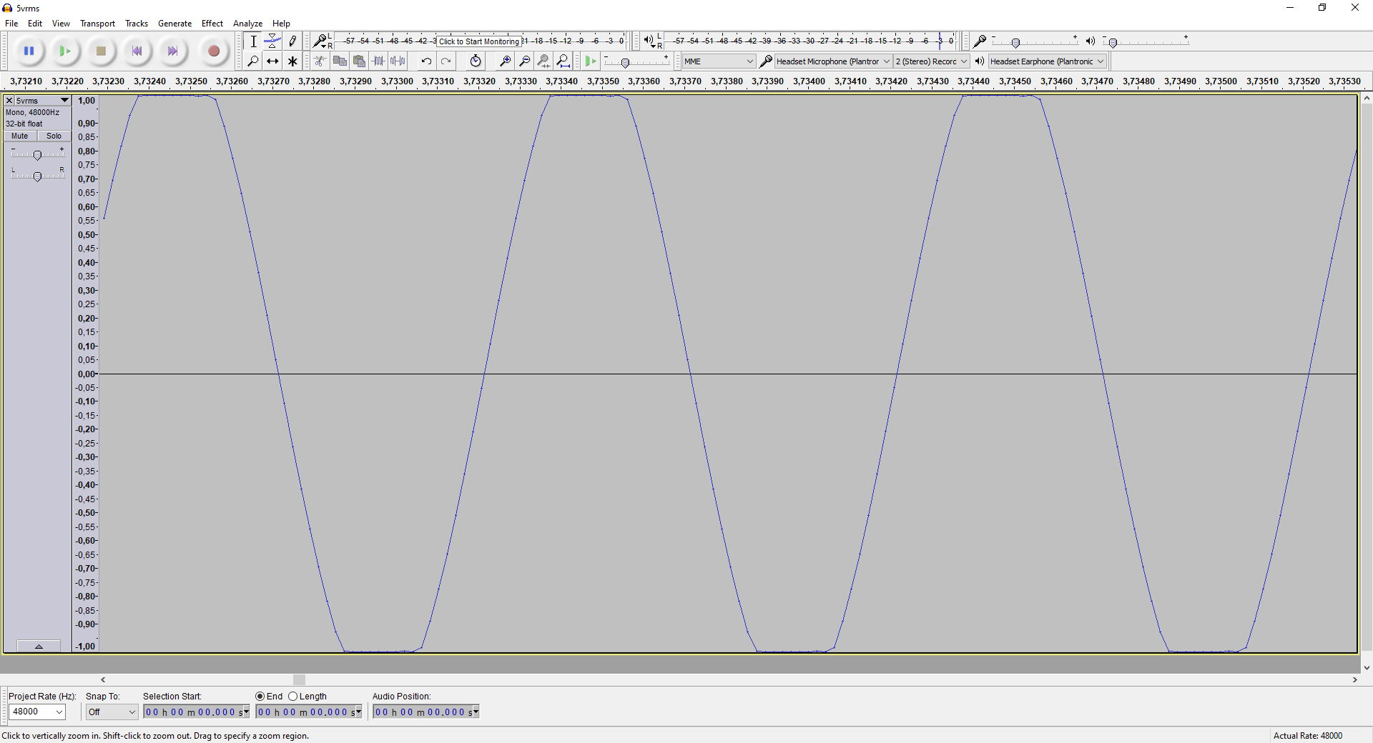

## Test Using ICOM Ringtone

##### Test 01

Intercom Volume: 50

Call Direction: Icom -> Cabin

Screenshot Num: 161

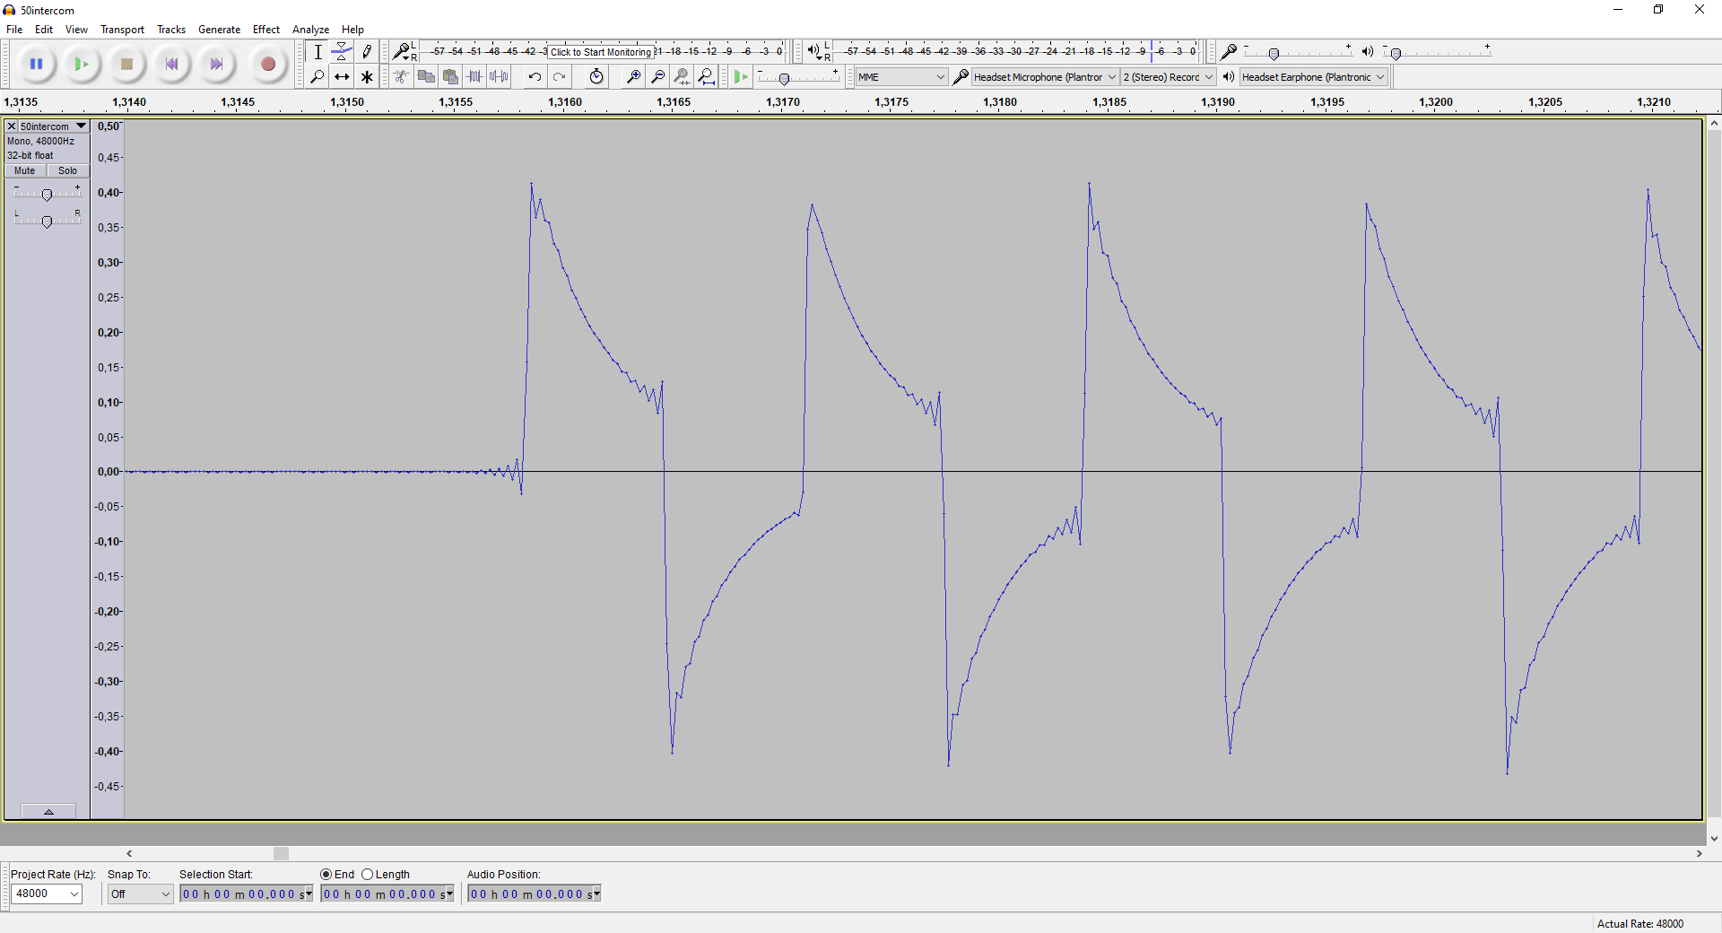

##### Test 02

Intercom Volume: 25

Call Direction: Icom -> Cabin

Screenshot Num: 162, 163, 165

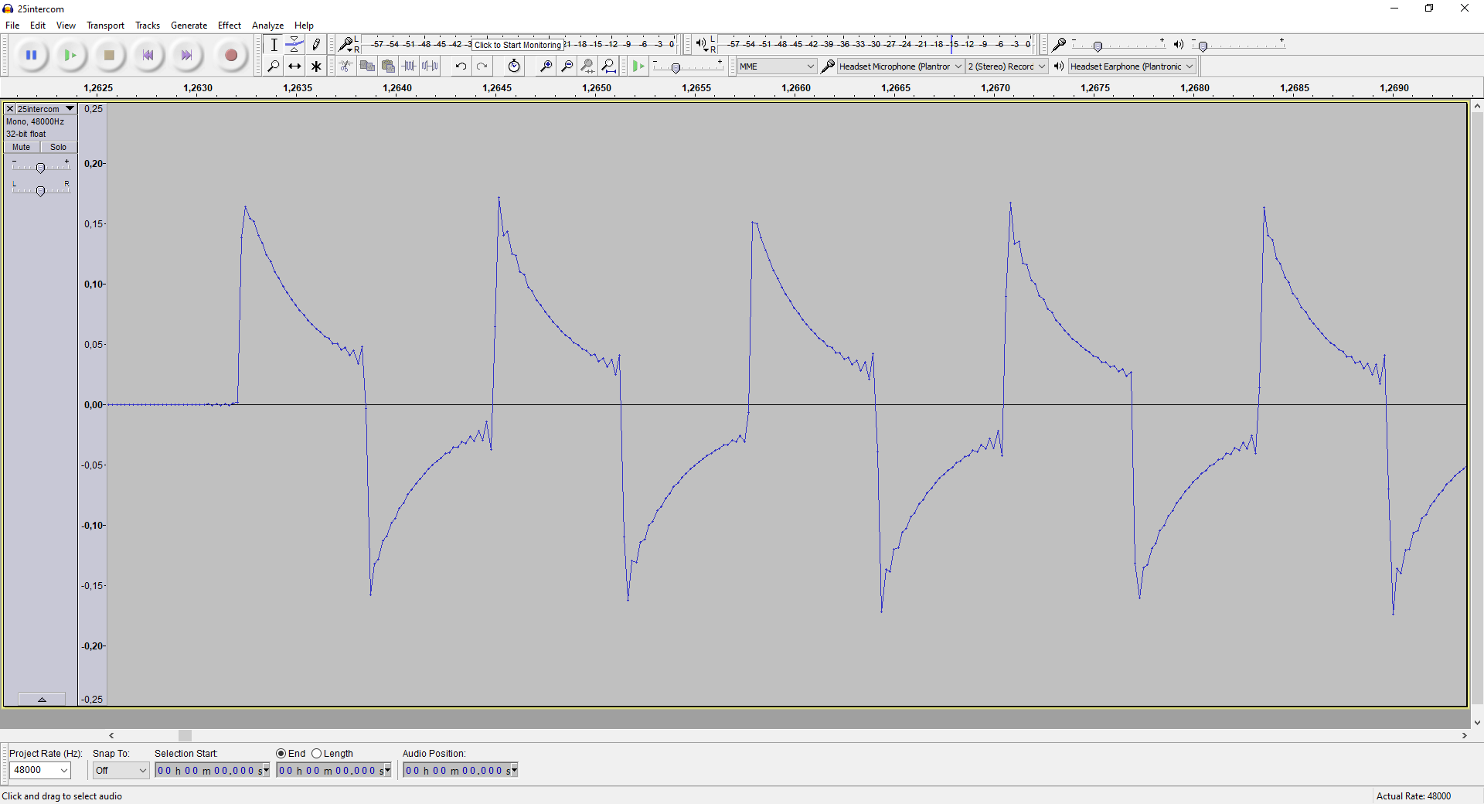

##### Test 03

Intercom Volume: 75

Call Direction : Icom -> Cabin

Screenshot Num : 166

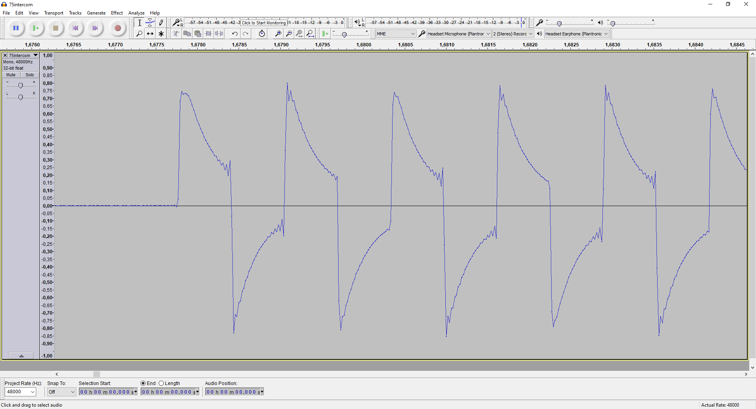

##### Test 05

Intercom Volume: 100

Call Direction: Icom -> Cabin

Screenshot Num: 167

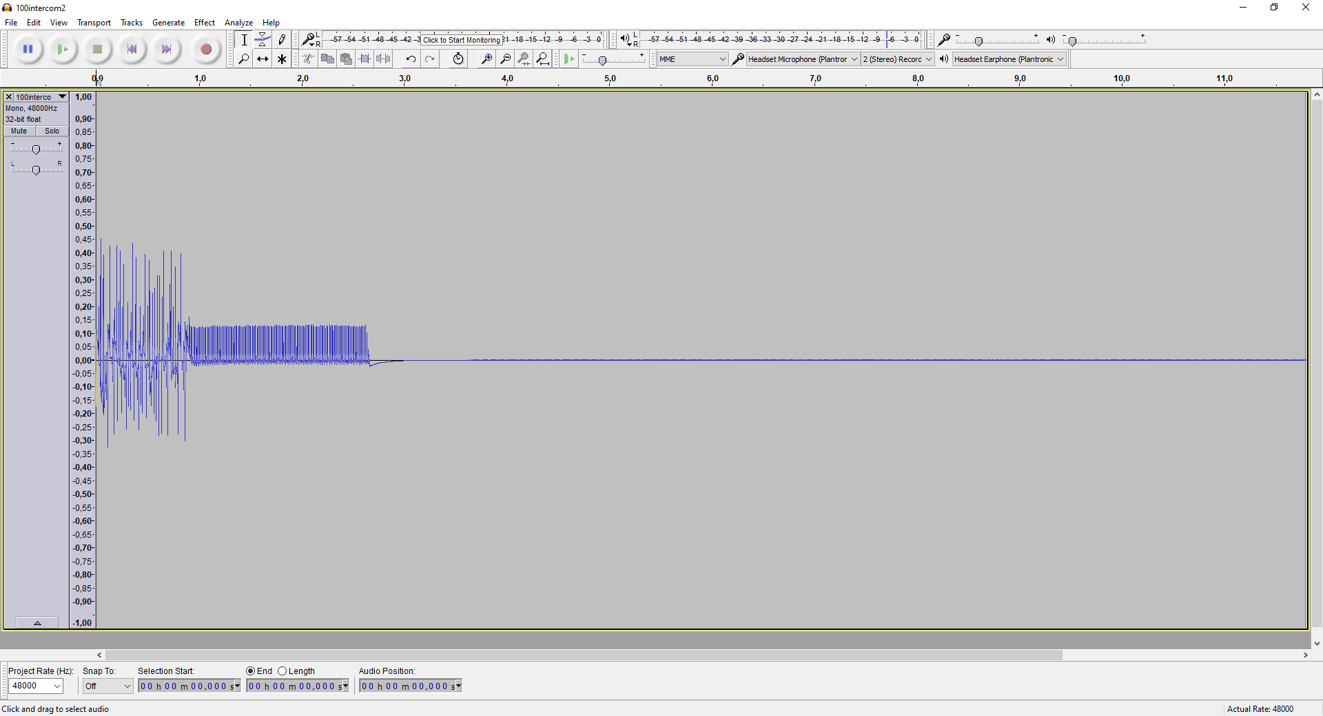

## Test Using Cellphone Tone - Generated @ -20db 1kHz

##### Test 05

Intercom Volume: 100

Call Direction: Icom -> Cabin

Screenshot Num: N/A

**TESTING NOT POSSIBLE - Unable to initiate call from ICOM to CABIN with ICOM volume @ 100**

##### Test 06

Intercom Volume: 100

Call Direction: Cabin -> Icom

Screenshot Num: 168

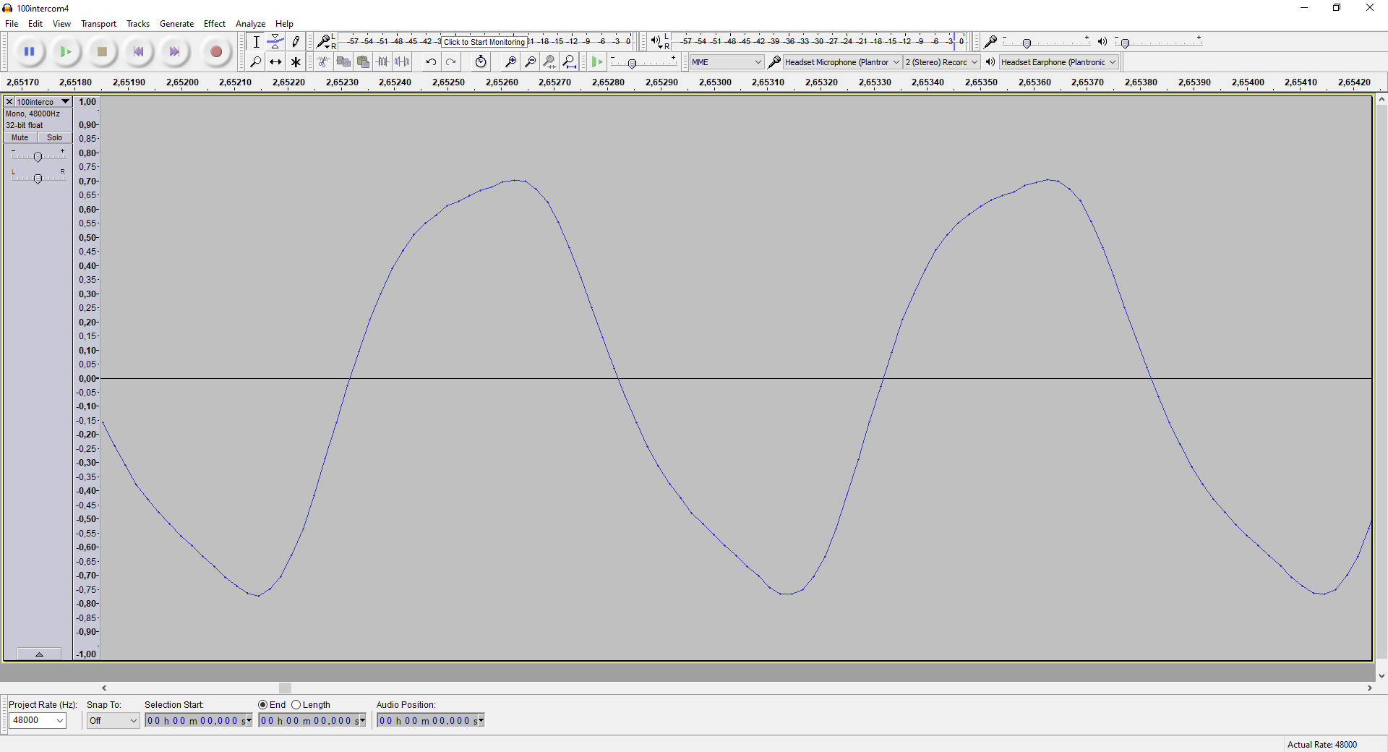

##### Test 07

Intercom Volume: 75

Call Direction: Icom -> Cabin

Screenshot Num: 169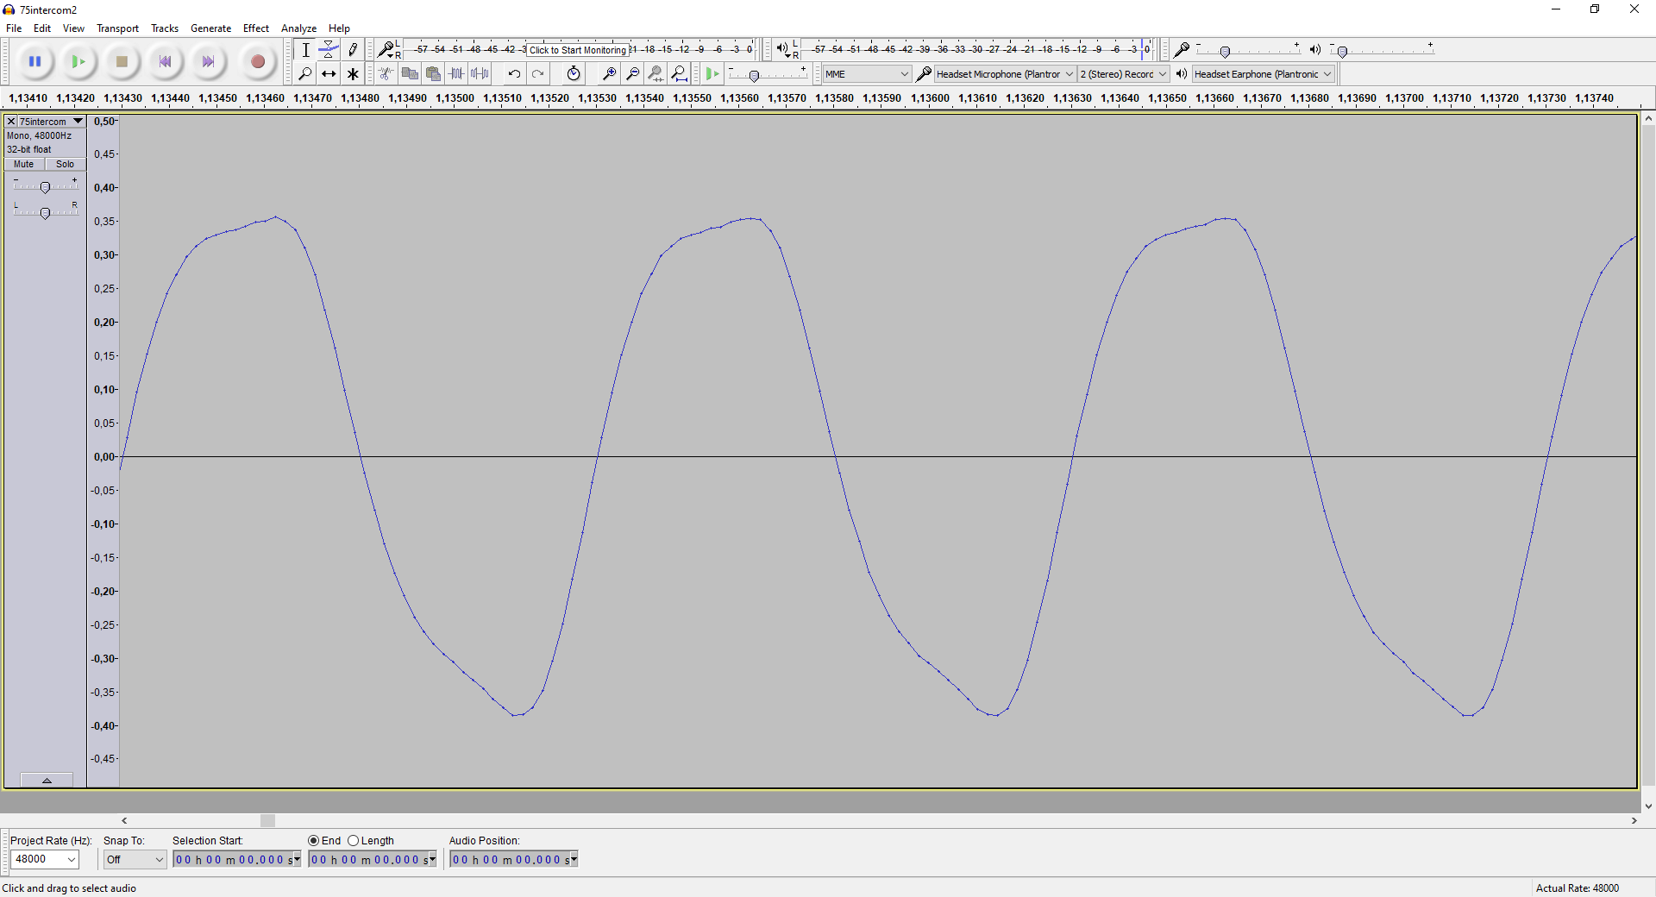

##### Test 08

Intercom Volume: 75

Call Direction: Cabin -> Icom

Screenshot Num: 170

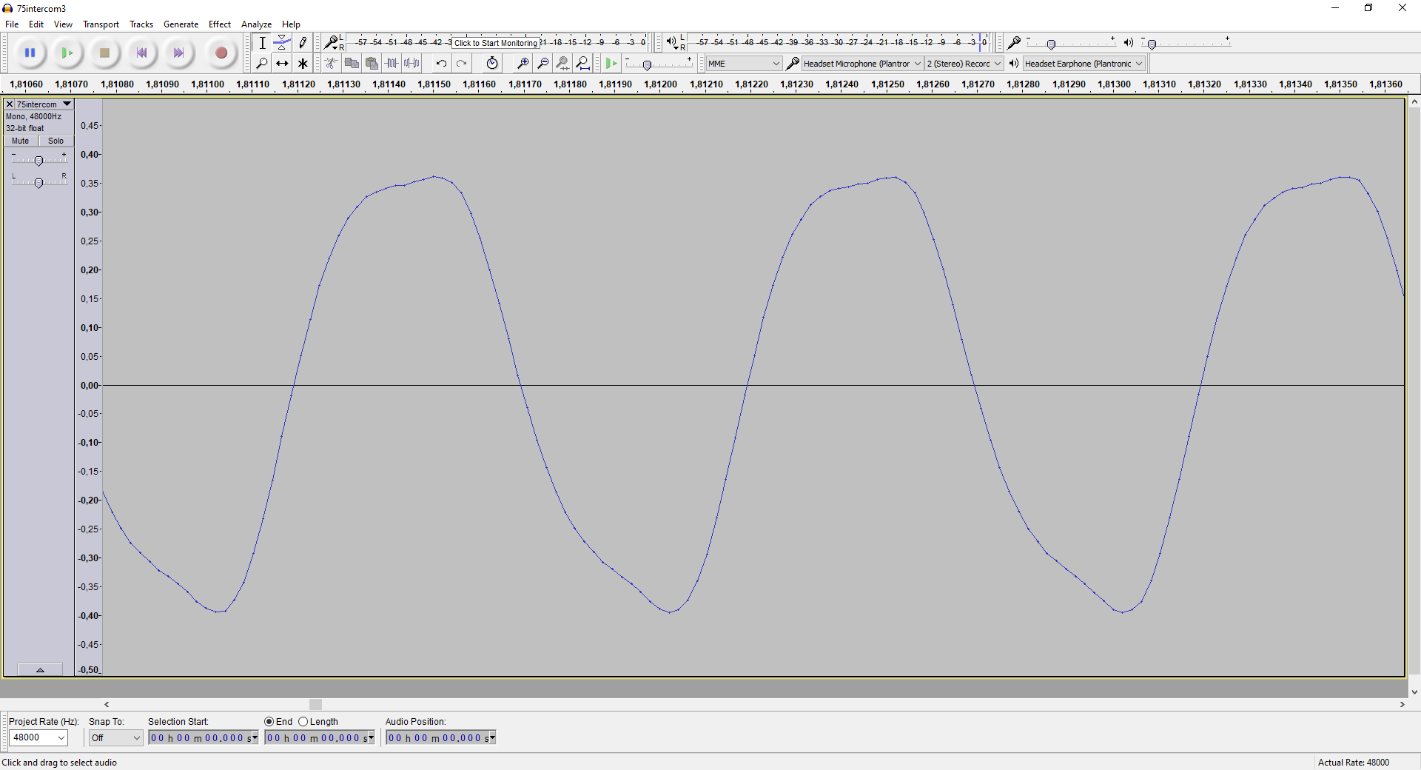

##### Test 09

Intercom Volume: 50

Call Direction: Icom -> Cabin

Screenshot Num: 171

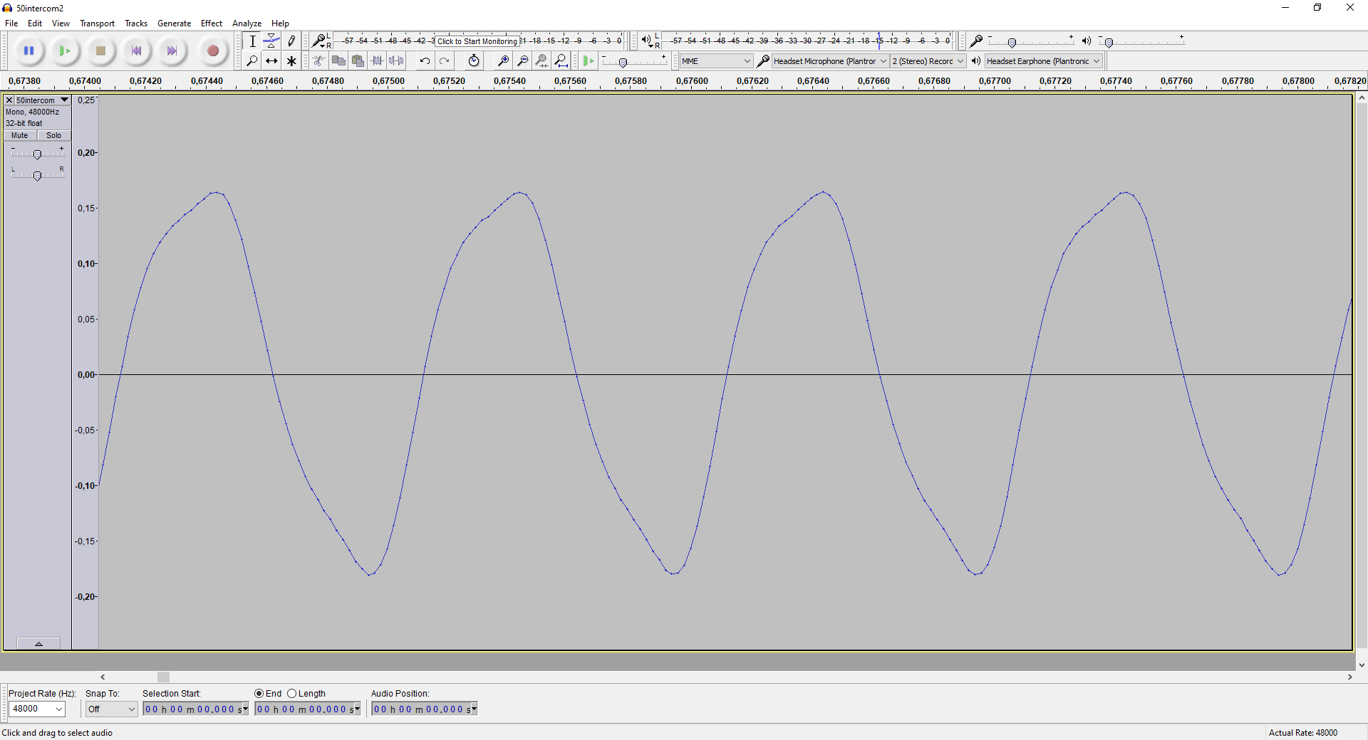

##### Test 10

Intercom Volume: 50

Call Direction: Cabin -> Icom

Screenshot Num: 172

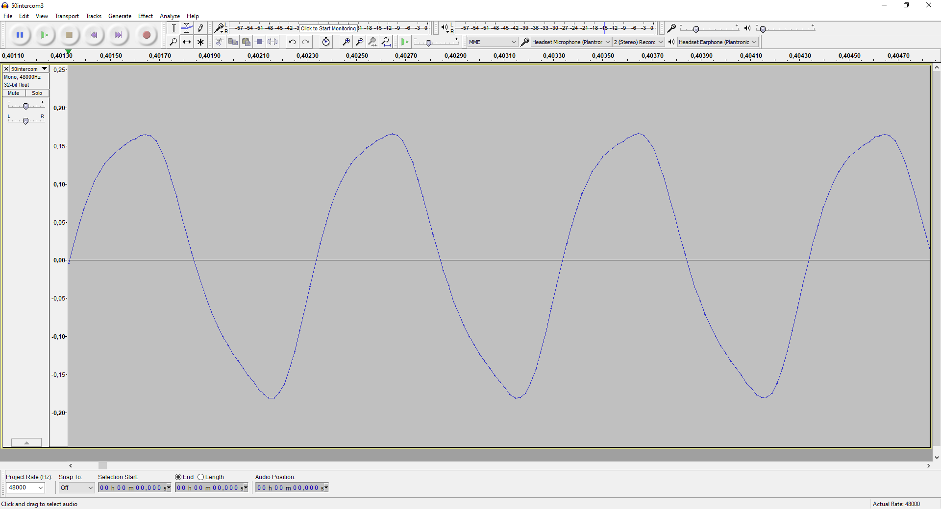

##### Test 11

Intercom Volume: 25

Call Direction: Icom -> Cabin

Screenshot Num: 173

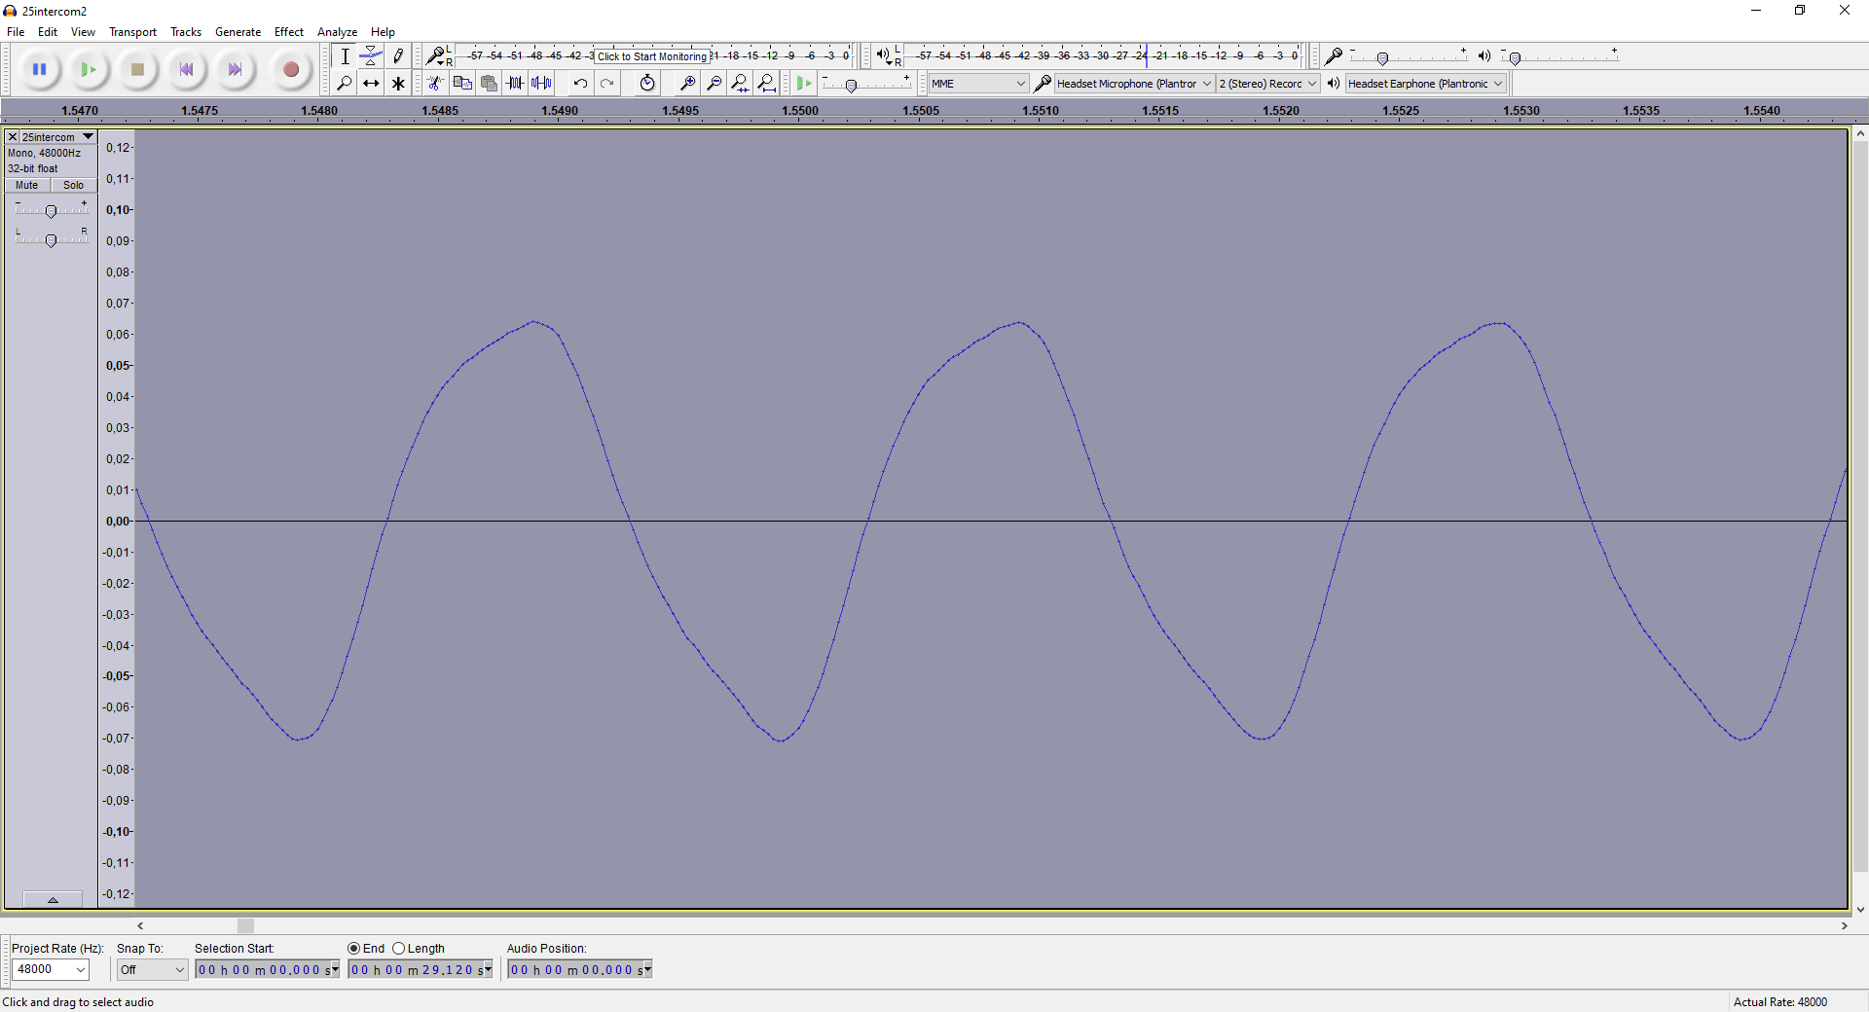

##### Test 12

Intercom Volume: 25

Call Direction: Cabin -> Icom

Screenshot Num: 174

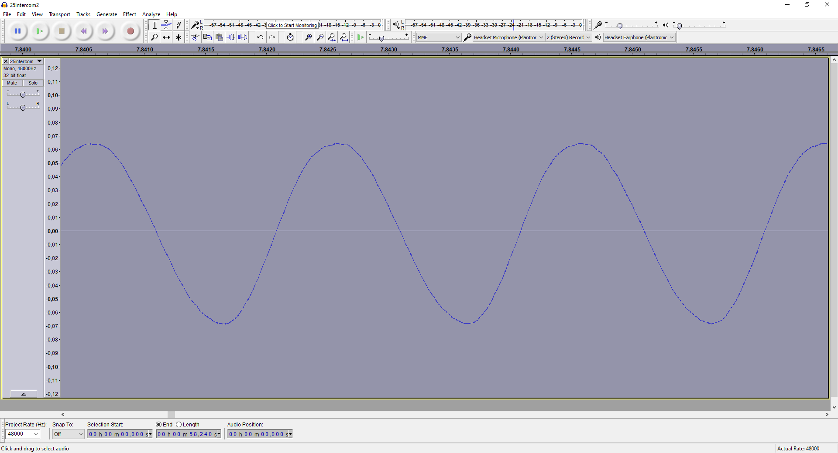

## Examples with Intercom Volume @ 100

